# Lesson 30 单词讲解

1. cut v. 穿过，切，割，剪，削

cut cut cut cutting

cut paper / one’s finger

cut sth. into pieces

把某东西切成碎片

cut and paste

cut down the tree / price 砍倒树 砍价

cut across the park

抄近路

1. sight n. 眼界，视域

in sight / out of sight

在视野/不再视野

catch sight of …

看见了什么

love at first sight

一见钟情

v. 看见，发现

1 [polo](http://dict.cn/polo.htm)['pəuləu] n.水球

[row](http://dict.cn/row.htm)[rəu, rou] v.划(船)

[kick](http://dict.cn/kick.htm)[kik] v.踢

[towards](http://dict.cn/towards.htm)[tə'wɔ:dz] prep.朝，向

[nearly](http://dict.cn/nearly.htm) ['niəli] ad.几乎

# Lesson 30 课文&语法讲解

1. The Wayle is a small river that cuts across the park near my home

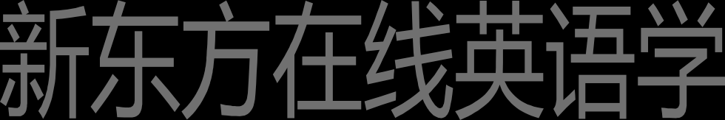2.I like sitting by the Wayle on fine afternoons.by 旁边

1. … so I went and sat on the river bank （堤岸）as usual.
2. Some children were playing games on the bank and there were some people rowing on the river.

There be 句型

扩展结构：There be + n. + 介词短语

There is a girl in the classroom.

There be + n. + doing There is a girl crying.

1. Some children were playing games on the bank and there were some people rowing on the river.

= some people were rowing on the river.

1. Suddenly, one of the children kicked a ball very hard and it went towards a passing boat. Doing 修饰名词 主动正在进行
2. Some people on the bank called out to the man in the boat...
3. I turned to look at the children, but there weren't any in sight…

So that 太。。以至于 接形容词副词

Such that 接名词

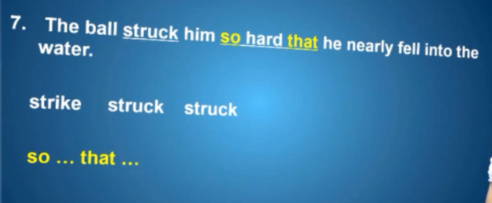

比较：

… there weren‘t any (children) in sight… Some people on the bank called out to the man…

… there were some people rowing on the river… 8.The man laughed when he realized what had happened.

蓝色部分是宾语从句 因为realized 是及物动词

laughed 是不及物动词，所以不是宾语从句

9.He called out to the children and threw the ball back to the bank.

# Lesson 30 知识拓展

补充内容: some / any

There is some water in your cup. There isn’t any water in your cup. Is there any water in your cup?

补充内容:

some / any

There are some students in the classroom. There aren’t any students in the classroom. Are there any students in the classroom?

补充内容:

some / any

I have some money in my pocket. I don’t have any money.